NEXUS INSTALL COMMANDS
UBUNTU :20.4
T2.MEDIUM
Step 1: sudo apt update
Step2 : sudo apt install openjdk-17-jre-headless -y
Step 3: goto browser and search download nexus and then select Download-sonatype-help option
Step 4: cd /opt/
Step 6: sudo wget https://download.sonatype.com/nexus/3/nexus-3.41.1-01-unix.tar.gz
Step 7:ls -ltr
Step 8: sudo tar -zxvf nexus-3.41.1-01-unix.tar.gz
Step 9:ls -ltr
Step 10: sudo mv /opt/nexus-3.41.1-01 /opt/nexus
Step 11:ls -ltr
Step 12 : sudo adduser nexus
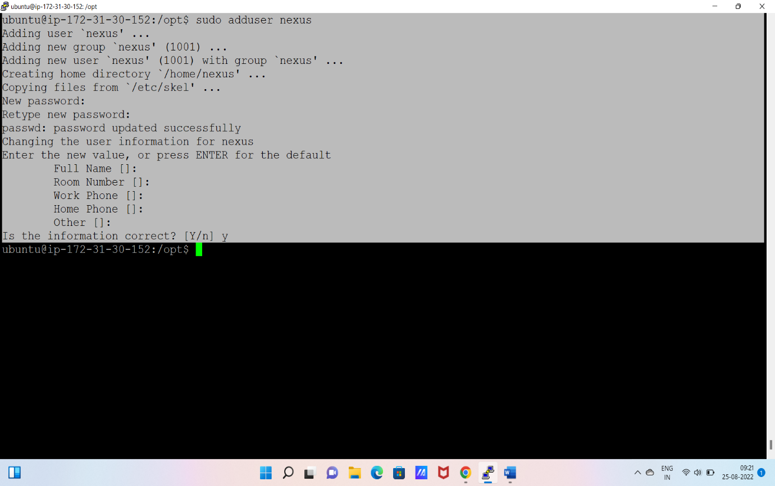
Step 13: sudo visudo
nexus ALL=(ALL) NOPASSWD:ALL
Save: ctr+x ctr+y enter
Step 14: ls -ltra
Step 15:sudo chown -R nexus:nexus /opt/nexus
Step 16: sudo chown -R nexus:nexus/opt/sonatype-work
Step 17: ls -ltr
Step 18: cd nexus/
Step 19: sudo apt install tree
Step 20: tree
Step 21: sudo vim /opt/nexus/bin/nexus.rc
#run_as_user=” “
Remove # and give name as nexus(“nexus”)
Save and quit
Step 22: sudo ln -s /opt/nexus/bin/nexus /etc/init.d/nexus
Step23: su – nexus
Give password
Step 24: /etc/init.d/nexus start
Step 25:sudo netstat -plnt
You need install sudo apt install net-tools
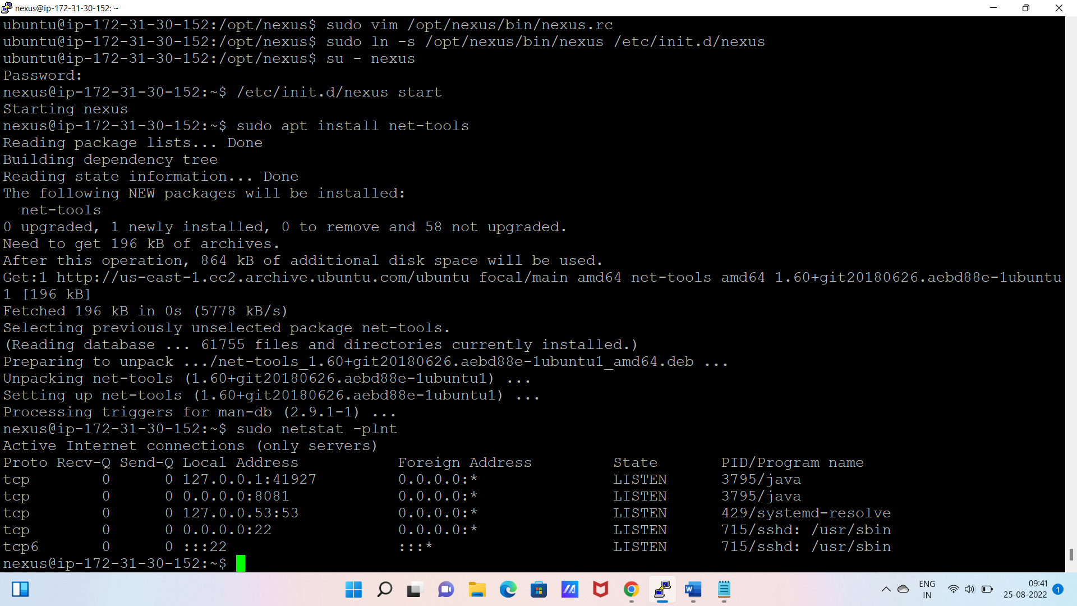

Step26: goto instance copy public and paste it into browser like(public ip:8081)
Step 27: click on sigin option (copy url path)
Step 28: cat paste url path and copy password
Now again sigin to the nexus username:admin and use password
Change your password



